St. Mary’s Church
Liverpool Rd,
Great Sankey,
Warrington WA5 1RE

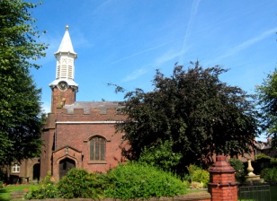
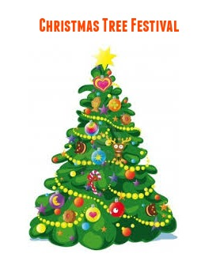
St. Mary’s Church Christmas Tree Festival ~ Saturday 9th December (11am-5pm)
This is a new event that we are hoping will be a great success and an opportunity to welcome the community to St. Mary's and show what wonderful things go on here and for us all to get into the spirit of Christmas!
If you belong to a group, an organisation or are a company that may like to get involved, the idea is that you provide your own tree and decorate it in a way that represents who you are (e.g., the Scouts may do a tree decorated in badges), or it could be decorated to represent a story from the bible, or it could even be decorated to represent part of the Nativity story the choice is yours. Battery operated lights must be used, and a plaque or sign would be useful giving details of your group and what your tree represents.
Setting up will take place the day/evening before (Friday 8th December) between 2pm and 7pm.
Entry to the Festival will be free, but seasonal refreshments will be available to buy for those visiting on the Saturday.
If you would like to reserve a space or would like more details please contact me on 07969 860294, or return the slip below to St. Mary’s Church ASAP.
Many Thanks
Mrs Clare Archibald (PCC Member)

~~~~~~~~~~~~~~~~~~~~~~~~~~~~~~~~~~~~~~~~~~~~~~~~~~~~~~~~~~~~~~~~~~~~~~~~~~~~~~~~~~~~~~~

St. Mary’s Church Christmas Tree Festival Booking Slip
Name of Organisation/Group/Company:
Contact Name:
Contact email address:
Contact Telephone Numbers:
The theme for our tree will be:

